Scenario_0116
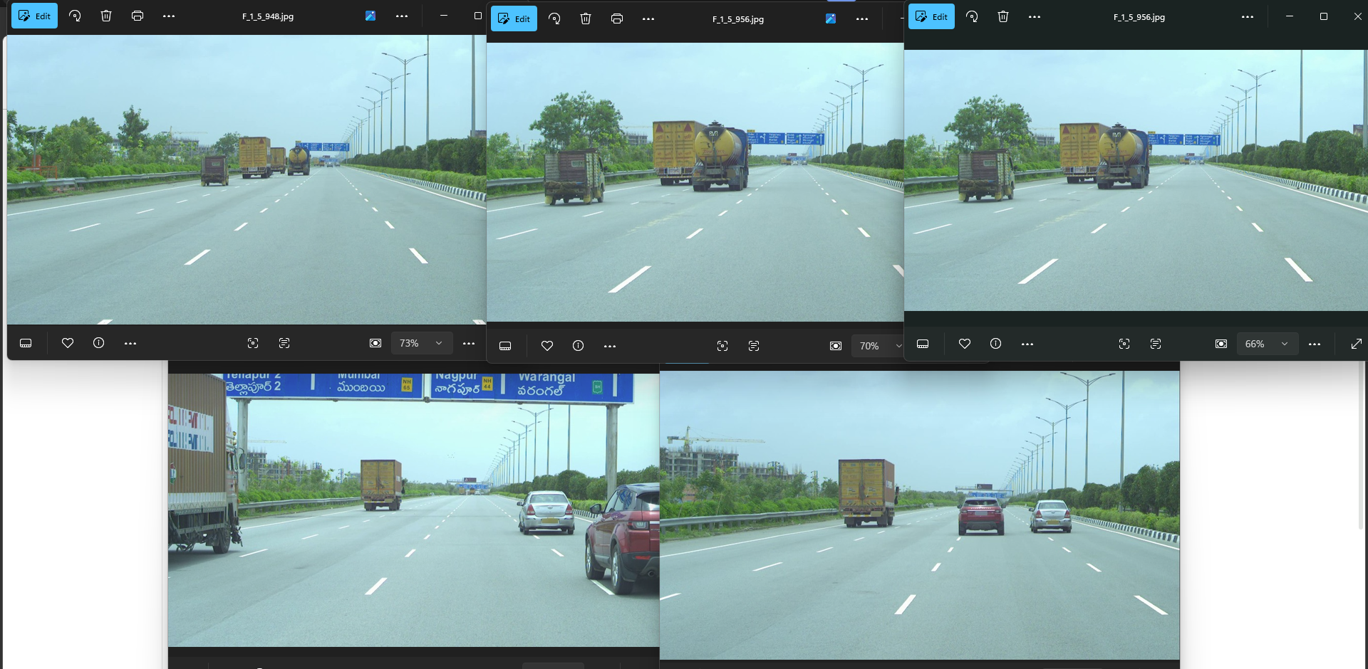

Perception and Action Planning Evaluation
This report presents the comparative analysis between human-verified ground truth data and model predictions for Scenario 0116. The evaluation focuses on spatial awareness and immediate hazard response, categorized by action-based decision making and scene understanding.

Evaluation Query | Ground Truth Annotation | Model Prediction
Are there any construction sites or roadworks visible in the distance? | Yes, there is a construction site visible in the distance on the left side of the road. | Yes, there is a construction site visible on the left side of the road.
What are your immediate next steps for navigating this road? | My immediate next step is to continue driving at a steady pace, maintaining a safe distance from the vehicles ahead. | My immediate next step is to continue following the truck ahead while maintaining a safe distance and adjusting my speed as necessary.
What are the most immediate, high-priority hazards you are focused on right now? | The most immediate hazard is the possibility of sudden braking or lane changes by the vehicles ahead. | The most immediate hazard is the truck ahead, which may slow down unexpectedly or change lanes without warning.

Scenario_1088
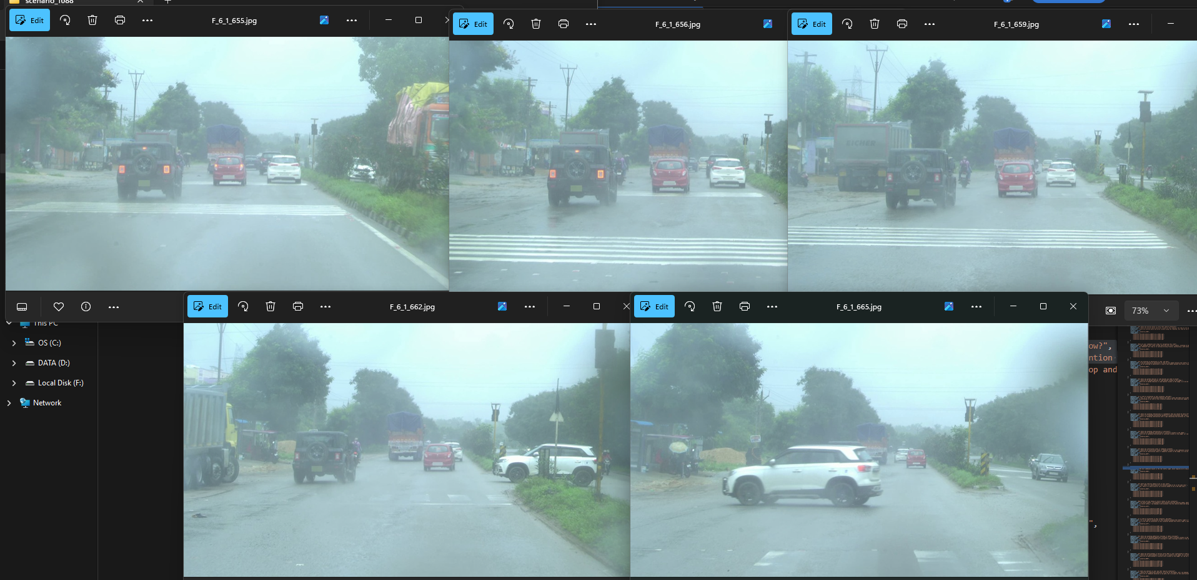
Evaluation Query | Ground Truth Annotation | Model Prediction
What is the current weather condition and how does it affect visibility? | The current weather condition appears to be foggy, reducing visibility significantly. | The weather appears to be foggy, reducing visibility significantly, which requires me to drive more cautiously and maintain a safe distance from other vehicles.
How are you anticipating the movement of the vehicle ahead? | I anticipate the red car ahead will continue moving forward, allowing me to merge into the right lane safely. | I anticipate that the red car will continue moving forward at its current speed, and I will adjust my speed accordingly to maintain a safe distance.
Is it safe to accelerate in this situation, and why? | It is not safe to accelerate in this situation because I am preparing to merge into the right lane, which may involve a change in speed and direction. | It is not safe to accelerate in this situation because the traffic ahead is moving slowly due to the foggy conditions, and accelerating could lead to losing control of the vehicle or colliding with another vehicle.

Scenario_0729
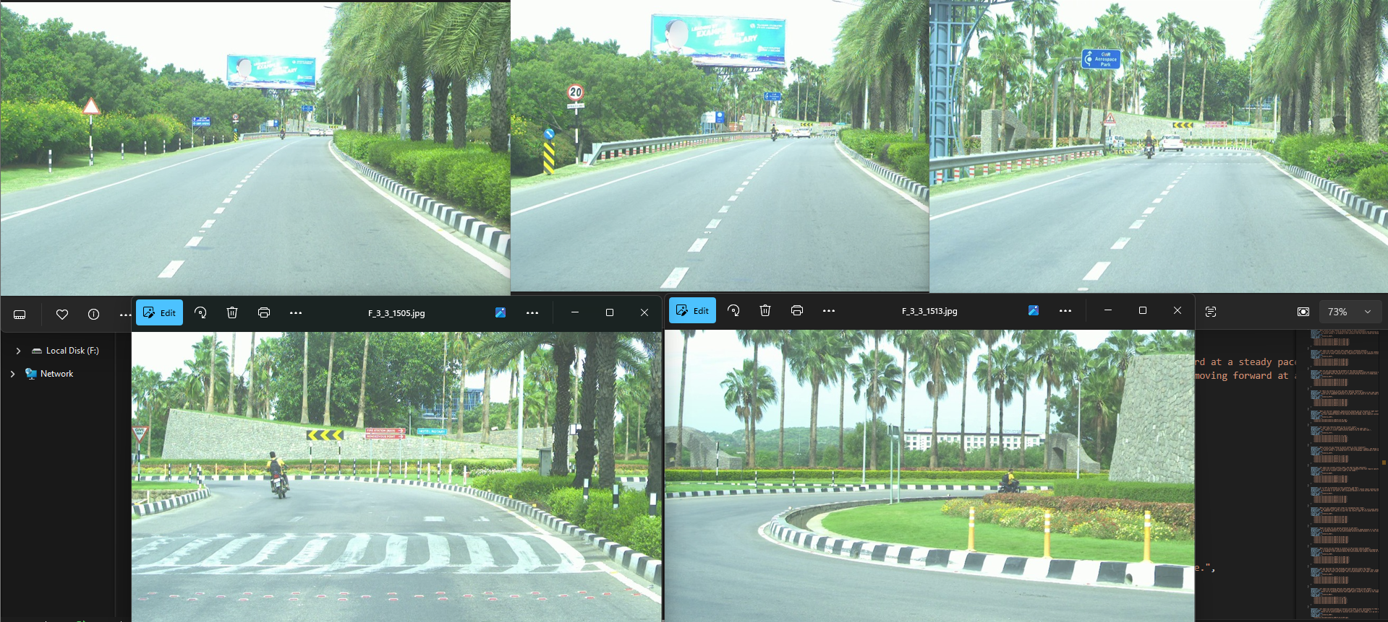

Evaluation Query | Ground Truth Annotation | Model Prediction
Are there any visible traffic signs, and what do they indicate? | There are traffic signs indicating the correct lane for the upcoming turn and a speed limit sign, which I am adhering to for safety. | There is a speed limit sign indicating 20 km/h, which I am following to ensure safety.
Are there any upcoming curves or bends in the road? | There are no upcoming curves or bends in the road, as the road is a straight path leading to the roundabout. | There is an upcoming curve indicated by the road signs, which requires careful navigation to ensure safety.

